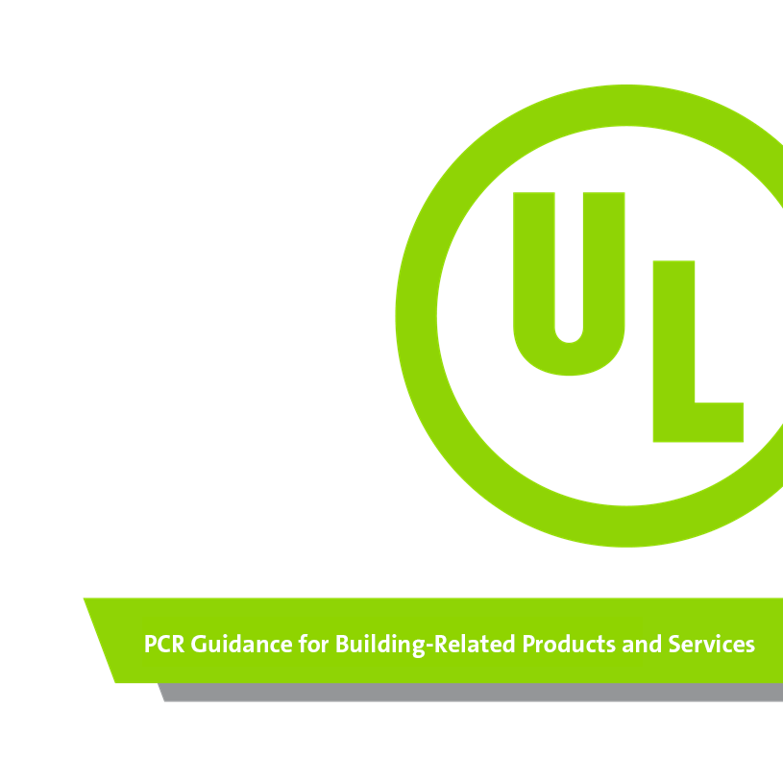
Part B: Cladding Product Systems
EPD Requirements
www.ul.com
Publisher: UL Environment

Tracking of versions
Version | Comments | History
1.0 | Version by UL Environment with input from external committee and accepted by an external review panel | 6/18/2015
2.0 | Creation of PCR Part B for Cladding Product Systems to conform with ISO 21930:2017 and UL Part A. This PCR has been updated to align with international standards with the intent of allowing manufacturers to create EPDs which are global in scope. | xxxxxx, 2020
© UL Environment
This PCR is valid for a period of five (5) years, set to expire in xxxxxxxx, 2025.

Background Information and Acknowledgements
These Product Category Rules (PCR) were developed to address the product specific rules for the creation of Environmental Product Declarations (EPDs) for cladding products and optional components such as fasteners, flashing, and other materials/systems that are part of the weather-resistant exterior wall envelope. Both cladding products and cladding systems are referred to throughout this document as "cladding product systems.” At the discretion of the Program Operator, this PCR may be applicable to cladding product systems not specifically described herein. When used to self-reference this document, “PCR” refers to “sub-category PCR” as defined in UL’s Part A PCR.
Other PCRs considered in the development of this PCR include:
- Product Category Rule (PCR) for Preparing an Environmental Product Declaration (EPD) for Product Group Cladding Product Systems, v1. UL. June 2015. (Previous version of this document)
- Part A: Life Cycle Assessment Calculation Rules and Report Requirements UL Environment December 2018, version 3.2)
- ISO 21930: 2017 - Sustainability in building construction -- Environmental declaration of building products
- EN 15804: 2012-04 - Sustainability of construction works - Environmental Product Declarations - Core rules for the product category of construction product.

This PCR assumes a minimum 75-year building service life (ASHRAE 189.1 2017, section 9.5.1.2.b) and International Green Construction Code 2018 section 901.5.1.2.

Interested Parties
This Part B has been prepared with input from the following stakeholders:
- Carbon Leadership Forum
- Building Diagnostics, Inc.
- James Hardie
- Polycor
- Vinyl Siding Institute

Governance
There are a number of representatives of cladding manufacturers and other stakeholders participating in the creation of this Product Category Rule (“PCR”) for cladding product systems, including those listed in the previous section. The very purpose and function of a trade association is to inform its members of important industry developments and to represent their interests in projects such as the update of a PCR affecting their products. In the development of this document, Part B, participants are responsible for ensuring alignment with Part A and conformance with the scoped standards: ISO 21930, EN 15804, and ISO 14025.
Involvement of Interested Parties
UL Environment shall be responsible for producing the PCR document by establishing an open consultation process that includes the involvement of interested parties (ISO 21930 Section 5.2 and 6.2.1). Reasonable efforts were made to achieve a consensus throughout the process (ISO 14020:2000, 4.9.1, Principle 8 and cited in both ISO 14025 and ISO 21930), demonstrated by a vote of participating interested parties.
UL Environment posted an open call for participation in this PCR update in May 2020 via its standards website, social media outlets, and outreach to original committee stakeholders.
Update Process
The PCR is valid for a duration of five (5) years from the publication date, at which time it may be revised at the request of industry stakeholders. The PCR may be revised before the five year date if the following occurs in the industry:
- The industry desires an update
- Core governing standards ISO 14040, 14044, 14025, 21930, or EN 15804 are updated with substantial material changes

Note: When the PCR is updated, the Program Operator shall communicate with the original committee and any new EPD participants, and initiate a new public call for interested parties.

Public Consultation
Public consultation was utilized during the PCR review process. The public consultation of the completed draft PCR included a minimum 30-calendar-day period for comments to be submitted to UL Environment. After public comments were submitted, the PCR committee reviewed and developed responses for all comments. All comments from the review panel and public consultation were addressed and satisfactorily resolved by the PCR committee prior to the publication of this PCR.

Review
The review process of this Part B PCR included a review through public consultation from xxxxx -- xxxxxx, 2020 and a panel review, comprised of the following individuals:

TBD | TBD | TBD

Scope
This document contains the Product Category Rule (PCR) requirements for Cladding Product Systems Environmental Product Declarations (EPDs) published in coordination with the ISO 21930 and EN 15804 standards. The requirements for the background Life Cycle Assessment (LCA) project report used to inform the EPD are contained in UL Environment’s Part A: Life Cycle Assessment Calculation Rules and Report Requirements. This Part B document, coupled with the Part A, conforms to the ISO 21930, EN 15804, and ISO 14025 sustainability standards for EPD reporting in addition to the US Green Building Council PCR Guidance.
This PCR has been updated to align with international standards with the intent of allowing manufacturers to create EPDs that are global in scope.
General Guidance

The scope of this PCR applies to the product group “cladding product systems” and includes all available building cladding products and their fasteners or other method of attachment, regardless of material type, except steel, as defined in the International Residential Code (IRC) and International Building Code (IBC).
Cladding consists of materials applied to a building exterior to separate a building from the natural environment and provide an outer building skin or layer, including, but not limited to, veneers, siding, exterior insulation and finish systems, architectural trim, and embellishments such as cornices, soffits, and fascia. Cladding provides control of weather elements to safely direct water and wind, and control run-off and infiltration of other foreign objects into the building structure. Cladding also provides a durable, aesthetically pleasing building appearance. Secondary roles can include, but are not limited to, sound and thermal insulation, structural performance, and fire resistance.
Applicable Products

Table 1 describes the cladding product systems covered within the scope of this Part B, along with their relevant Construction Specification Institute (CSI) MasterFormat codes. This list is non-exhaustive, and the CSI numbers provided reflect common applications, which can include multiple uses; other applications may exist. Applicable UNSPSC codes and UNCPC codes include:

Table 1. Cladding Products and Masterformat Number
Cladding Product System | CSI number(s) | CSI title
Stone masonry and Cladding | 044200  044300 | Exterior Stone Cladding  Stone Masonry Veneer
Siding and Wall Panels | 074000  074200 | Wood Wall Panels  Tile Wall Panels  Terra Cotta Wall Panels  Plastic Wall Panels  Composite Wall Panels  Cementitious Wall Panels  Fabricated Wall Panel Assemblies  Soffit Panels  Stone Wall Panels
Faced Panels | 074400 | Aggregate Coated Panels  Porcelain Enameled Faced Panels  Tile-Faced Panels  Ceramic-Tile-Faced Panels  Glass-Fiber-Reinforced Cementitious Panels Mineral-Fiber-Reinforced Cementitious Panels Fabricated Faced Panel Assemblies  Stone Faced Panels
Siding | 074600 | Wood Siding  Wood Shingle and Shake Siding  Wood Shingle Siding  Wood Shake Siding  Hardboard Siding  Plywood Siding  Plastic Siding  Composition Siding  Fiber-Cement Siding  Fabricated Panel Assemblies with Siding  Stone Siding

The products considered in this PCR fall under UNSPSC codes:
- 30161505 Panels or panelling
- 30151800 Siding and exterior wall materials
- 30151802 Siding
- 30151807 Exterior trim material
Non-Applicable Products
The following products, which may provide similar functions in a different application, are not within the scope of this PCR:
- Solar panel cladding products (their primary function is not cladding, but to generate electricity).
- Steel cladding products (covered in the Steel Construction Products PCR v2. UL, July 2020).
- Insulated Metal Panels, Metal Composite Panels, and Metal Cladding (covered in Part B: Insulated Metal Panels, Metal Composite Panels, and Metal Cladding. UL, October 2018).
- Roofing products
- Stucco products
System Boundary
The system boundary for EPDs created using this PCR may be chosen from the following options:

- Cradle to gate (modules A1-A3), or
- Cradle to gate with options (modules A1-A3, optional modules A4, A5, B4, C1-C4), or
- Cradle to grave (modules A1-A3, A4, A5, B1-B6, C1-C4, and optional module D).

See Part A, Section 2.8 for further discussion of the required and optional information modules included in each EPD type. Module D is not a life cycle stage like the information modules A1 to C4 and is outside the system boundary of the studied product system and construction works system. Supplementary environmental information may be provided in Module D that addresses potential loads and benefits beyond the product system boundary.

The EPDs produced under this PCR do not cover the operational impacts of the whole building.

At this time, there is no industry consensus for assumptions behind the reported scenarios for information modules A4, A5, B2, or C1 – C4 across each of the subcategories of cladding products included in this PCR.

The EPD requirements include:
- ISO 21930:2017 standard
- EN 15804:2012+A2:2019 standard (optional)
- ULE General Program Instructions v 2.5, March 2020 (available upon request)
- Calculation rules for the Life Cycle Assessment and Requirements on the Project Report (are specified in a separate document as Part A v3.2 of the Product Category Rules, available at https://www.ul.com/offerings/product-category-rules-pcrs).

Industry-Average EPD Requirements
Industry-Average EPD Scope
The products represented within a single industry-average EPD created using this PCR are limited to the primary materials defined in the product specification standards in Section 9, which characterize the specific product in commerce.

Involvement of Interested Parties
A call for involvement of interested parties in the creation of an industry-average EPD shall be published in at least one industry trade publication. At a minimum, at least three (3) different manufacturing locations from no less than three (3) companies should be involved and represented in an industry-average EPD. The method for determining representativeness shall be justified and described per the requirements listed in Section 2.2.3.

Industry-Average EPD Participation
A manufacturer qualifies for participation in an industry-average EPD created using this PCR if they provide primary manufacturing data used in calculating the initial EPD average or demonstrate willingness to provide primary manufacturing data during the LCA data collection process.

Retroactive participation
When determining a manufacturer’s participation eligibility, the EPD Program Operator shall follow the rules and recommendations of the primary sponsor(s) of the industry average EPD and participating manufacturers.
If deemed eligible, a manufacturer desiring retroactive inclusion in the industry average EPD shall provide manufacturing and product data information of the same representativeness submitted in the original industry average EPD to the LCA practitioner. The LCA practitioner will then recommend to the Program Operator a determination for inclusion in the industry average on the basis of results falling within a reasonable range of 15% variance for any impact category. The maximum and minimum should be reported in the LCA background report for each impact category based on the highest and lowest impact product or facility within the original industry-average LCA.
Governance
An industry organization shall inform possible industry participants through association meetings, newsletters, email messages, notices in the trade press publications,and similar types of outreach. Confidential business information shall be collected by a third party. Data from the third party shall be provided to the facilitator as aggregated data with no trace to the original source of data.

The development of an industry-average EPD and or update of an EPD should involve a series of meetings and exchanges in which all participants are invited and kept apprised of the developments. Notices of these meetings should be given to all possible participants regardless of their commitment to active involvement. Minutes of meetings, along with meeting notices, should be preserved as documentation of the process and due diligence observed in the creation or renewal of the EPD.

Data Responsibility/Ownership
Trade associations that lead the development of industry-average EPDs may need to collect confidential business information from individual members. This data can include proprietary chemical formulations and processes or other confidential information. In this case, a designated third-party entity such as an LCA practitioner shall be identified as the “industry agent.” The industry agent shall be responsible for collection, secure storage and analysis of such data needed for the EPD development, and shall preserve the privacy of individual company information while executing these duties.
Per ISO 21930 Section 5.4, the manufacturer, or group of manufacturers, of the construction product is the sole owner of the EPD and is responsible for developing the EPD of the construction product according to the PCR. Only the manufacturer or group of manufacturers is authorized to declare the environmental performance of the construction product using an EPD.
The group of manufacturers responsible for developing an industry-average EPD shall be responsible for ensuring industry-average EPD updates are made based on the most recent available LCA modelling software version and impact assessment version.
EPD Updates
EPDs created using this PCR shall expire five (5) years after publication. An update to the existing EPD, or new EPD, may need to be developed prior to the five year review if any of the following have occurred (non-exhaustive):

- Significant changes in the manufacturing process;
- New manufacturers desire to participate that are disqualified for retroactive participation on the basis of provided data;
- Significant changes or alterations in raw materials;
- Major regulatory changes; or
- Major technological changes.

Content of the EPD
EPD Program and Program Operator Name, Address, Logo, and Website | Program Operator Provided
General Program Instructions & Version | Program Operator Provided
Manufacturer Name and Address
Manufacturer Location(s)
Declaration Number | Program Operator Provided
Declared Product & Functional Unit or Declared Unit
Reference PCR and Version Number
Description of product’s intended application and use (as Identified when Determining Product RSL)
Product RSL Description (if Appl.)
Markets of Applicability
Date of Issue | Program Operator Provided
Period of Validity | Program Operator Provided
EPD Type | [Industry-average or product-specific]
Dataset Variability | [Industry-average only; mean, median, standard deviation]
EPD Scope | [Cradle to gate, cradle to gate with options (specify options), cradle to grave]
Year(s) of reported primary data
LCA Software & Version Number
LCI Database(s) & Version Number
LCIA Methodology & Version Number
The sub-category PCR review was conducted by: |  | Program Operator Provided
 |  | Program Operator Provided
 |  | Program Operator Provided
This declaration was independently verified in accordance with ISO 14025: 2006. The UL Environment “Part A: Calculation Rules for the Life Cycle Assessment and Requirements on the Project Report,” v3.2 (December 2018), in conformance with ISO 21930:2017, serves as the core PCR, with additional considerations from the USGBC/UL Environment Part A Enhancement (2017)
☐ INTERNAL ☐ EXTERNAL
 |  | Program Operator Provided
This life cycle assessment was conducted in accordance with ISO 14044 and the reference PCR by:
 |  | Program Operator Provided
This life cycle assessment was independently verified in accordance with ISO 14044 and the reference PCR by:
 |  | Program Operator Provided
Limitations
Environmental product declarations from different EPD programs (ISO 14025) may not be comparable.
Comparison of the environmental performance of Cladding Product Systems using EPD information shall be based on the product’s use and impacts at the building level, and therefore EPDs may not be used for comparability purposes when not considering the building energy use phase.
Full conformance with this PCR allows EPD comparability only when all stages of a life cycle have been considered.See Section 3.10 for additional EPD comparability guidelines.

General Information
The comprehensive requirements for EPD content are specified in Part A, Section 7 and ISO 21930:2017, Section 9 (Clause 9).

Description of Organization

Product Specific EPD
The name of the manufacturing entity(ies) as well as the place(s) of production shall be provided.General information about the manufacturing entity(ies) may be provided, such as the existence of quality systems or environmental management systems, according to ISO 14001 or any other environmental management system in place.

Industry Average EPD
The name of the sponsoring organization as well as participating manufacturers shall be provided or linked via URL.

Product Description
A narrative description of the products shall be provided that enables clear identification. This description will include:

Product Identification
The declared products shall be identified by brand name(s), by material type(s), by production code(s) (if applicable), and by simple visual representation, which may be by photograph or graphic illustration.
Example: Polypropylene siding produced according to the standard ASTM D7254 Standard Specification for Polypropylene (PP) Siding.

Product Specification
Related products grouped and reported as an average product in the same EPD satisfying the variation criteria of Part A, Section 2.5.2 shall constitute an individual declared product. For each declared product, list the physical characteristics – in the form that the product would be installed – along with the reference to the test standard for each. When pertinent, provide a description of the products. Other relevant product specification values may be provided here.

Flow Diagram
A graphical depiction (i.e. flow diagram) illustrating the life cycle of the product according to the scope of the declaration shall be included such as the example in Figure 1.
Figure 1. Example Product Flow Diagram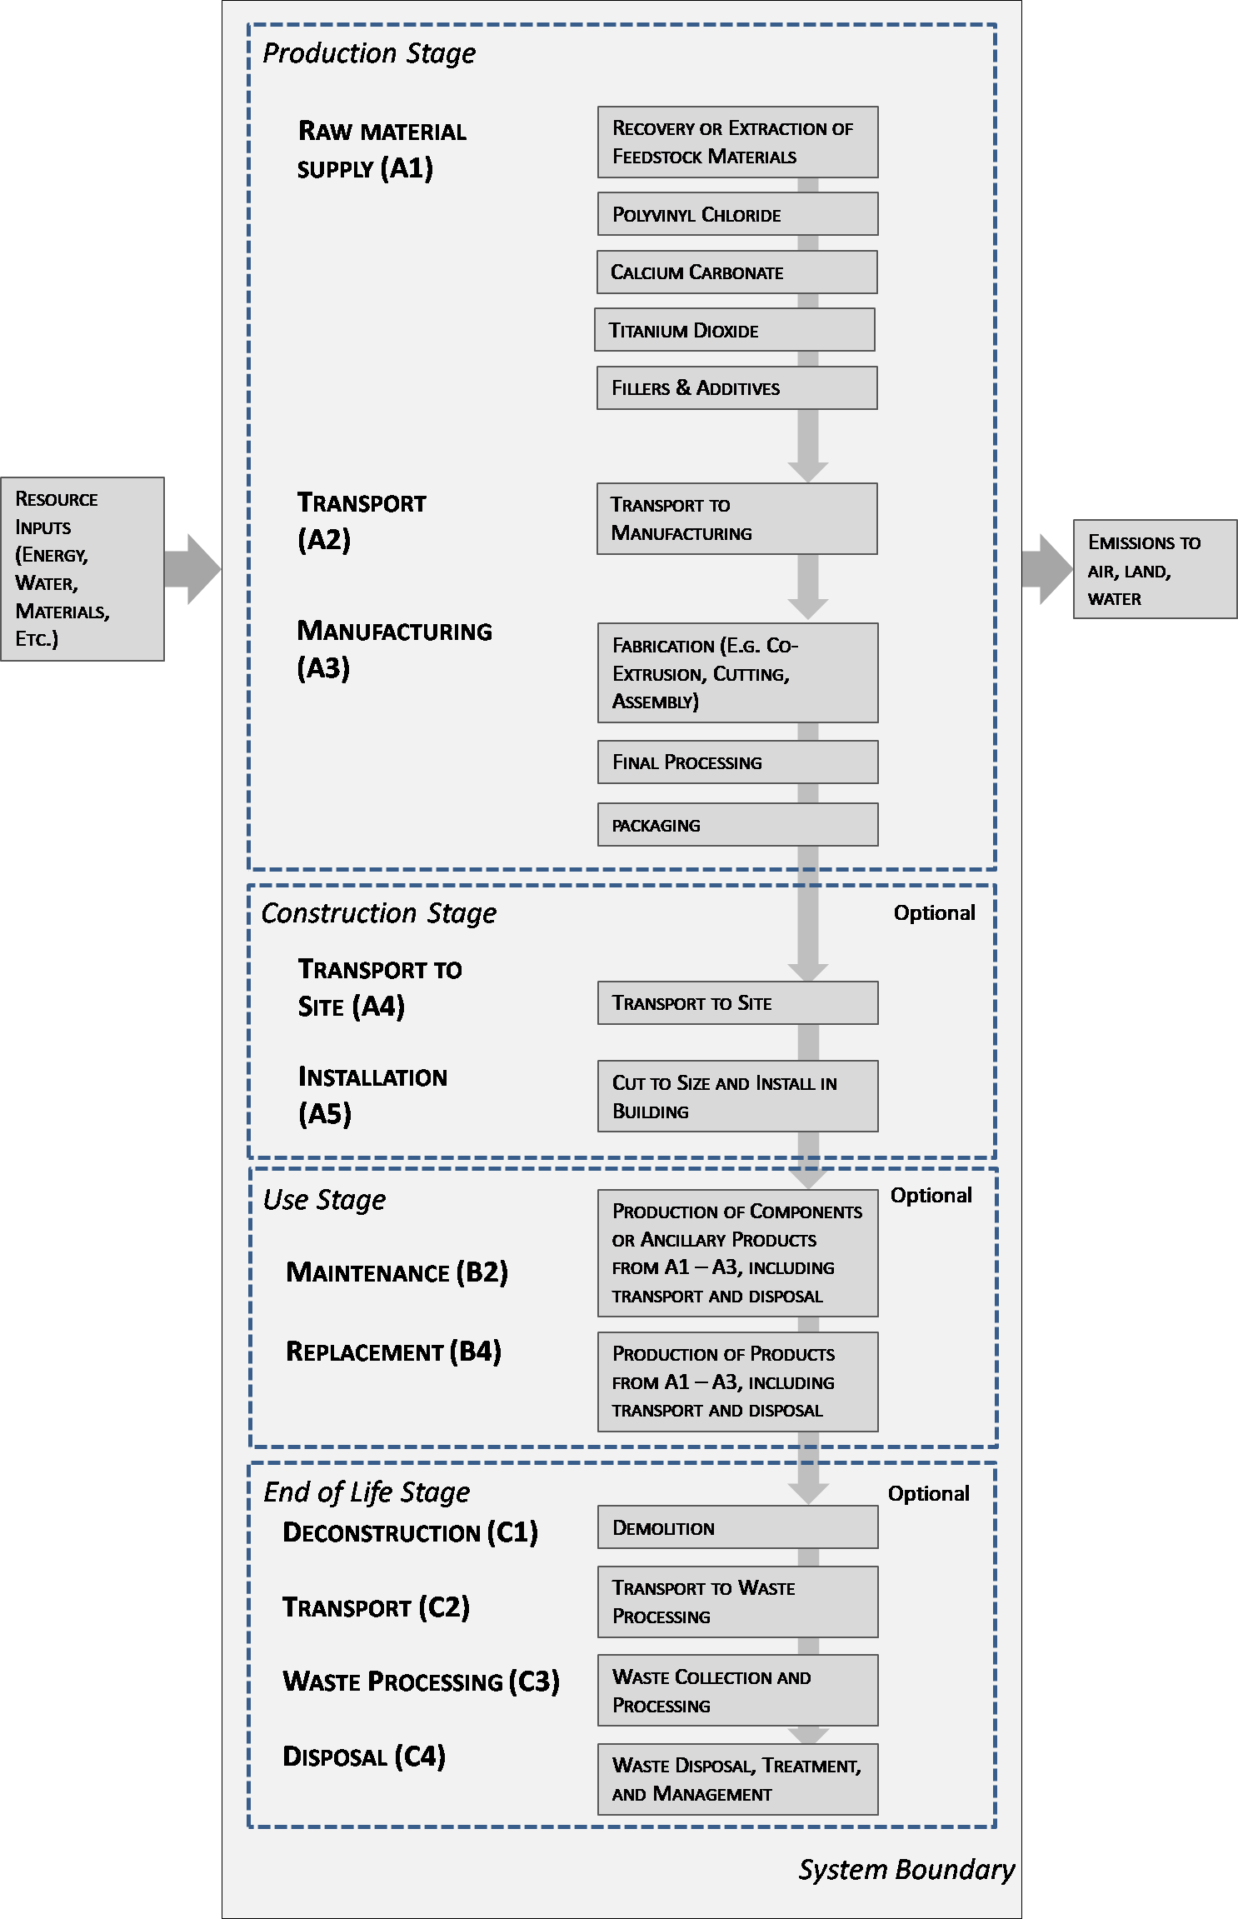

  - Product Averages for EPDs
    - Product Specific EPD
The method for creating a company-specific individual product/product group EPD shall be described, including the method for determining a weighted average across products based on production volume as described in Part A, Section 2.5.2.

    - Industry Average EPD (if relevant)
The method for creating an industry-average EPD shall be described per Part A, Section 2.5.1.

Application
The applications of the declared product(s) shall be described.

Material Composition
The main components or materials that make up the product shall be described and given in percentage by mass. Materials and components include, but are not limited to, general categories such as PVC, calcium carbonate, cement, silica, wood, resins, impact modifier, fillers, and additives.

Statements of material non-inclusion, such as “free of” may not be used. Ancillary materials and additives remaining in the product shall also be declared.
Regulated substances shall be reported per Part A, Section 4.11.
Note: This disclosure is intended to enable the user of the EPD to understand the composition of the product in delivery condition and support a safe and effective installation, use, and disposal of the product. With appropriate justification, this requirement does not apply to confidential or proprietary information relating to materials and substances due to a competitive business environment or covered by intellectual property rights or similar legal restrictions. It also might not be appropriate for information concerning intangible products.

Properties of Declared Product as Delivered
The final evaluation report/certification/registration is available at: [Insert link]

Methodological Framework
The following items shall be specified: the type of EPD with respect to life cycle stages, and the life cycle stages covered and not covered.

Declared and Functional Unit
A declared unit shall be applied if the precise function of the product is not stated or not known. The declared unit shall be one (1) square meter of product, as manufactured, and optionally one hundred (100) square feet of cladding product. Conversion factors (e.g., density, thickness, surface area, etc.) shall be provided to allow the users to conduct further calculations (e.g., transport impacts).
For EPDs covering the complete life cycle, a functional unit shall be defined based on the functional use or performance characteristics of the product integrated into a building or other type of construction in the use phase. The functional unit shall be defined in Table 2, including the reference service life (RSL). The reference flow as an input to enable cladding products to meet the functional unit requirements shall include related accessories and other materials (e.g., fasteners), unless the reason for the omission of these is explained.
Environmental impact results based on a declared unit of a cladding product do not provide sufficient information to establish comparisons. The results shall not be used for comparisons without knowledge of how the physical properties of the cladding product impact the precise function at the construction level. The environmental impact results shall be converted to a functional unit basis before any comparison is attempted. See Section 5.1 for additional EPD comparability guidelines.
Table 2 summarizes declared units and functional units that are applicable for cladding products and the associated properties shall be indicated in Table 3 as declared, if relevant, with appropriate test method.
Table 2. Declared and Functional Units
Product | Declared unit | Functional unit
Cladding products | Required: One square meter 1 m² of manufactured cladding products  Optional (in addition to 1 m²): One hundred square feet (100 ft² ) of manufactured cladding products  Optional (in addition to 1 m²): One square foot (1 ft²) of manufactured trim products | Required: One square meter (m²) of installed product  Optional (in addition to 1 m²): One hundred square feet (100 ft² ) of installed cladding product  Optional (in addition to 1 m²): One square foot (1 ft²) of installed trim product

Table 3. Functional or Declared Unit Properties
Name | Value | Unit
Functional or Declared unit
Mass |  | kg
Thickness to achieve Functional or Declared Unit |  | m
Density |  | kg/m³
Length |  | m
Width |  | m
Tensile strength |  | Required: MPa  Optional: Ibf/in² (PSI)
Modulus of Elasticity |  | Required: MPa  Optional: Ibf/in² (PSI)
U-value of assembly including interruptions to insulation |  | Required: W/m²·K  Optional: BTU/(h °F ft²)
R-value of typical materials where continuous |  | Required: m²·K/W  Optional: ft²·°F·hr/BTU
Water vapor permeance |  | Required: metric perms Optional: US perms (inch-pound)
Liquid water absorption |  | % of dry weight
Airborne sound reduction |  | dB
Sound absorption coefficient |  | %

  - System boundary
    - General
The type of EPD shall be specified as cradle to gate, cradle to gate with options (end of life), or cradle to grave. The modules considered shall be described in brief in the EPD and justified in the LCA as per “System boundaries” outlined in Part A, Section 2.8. It should be apparent as to what processes are considered in what modules per the module descriptions in Part A, Section 2.8. Any relevant aspects or impacts not included in an information module shall be supported with relevant additional environmental information and the omissions shall be justified. Module D is not an information module and shall be reported separately if included in the EPD.
Capital goods and infrastructure flows shall be excluded from the product system boundary.
    - Module D
Module D reports the potential benefit or burden from the displacement of primary materials and/or fuels associated with recycling and recovery at end‐of‐life. When optional Module D is reported in an EPD, the EPD shall explicitly describe the methodology used to calculate the reported values, including the LCI of scrap used in calculations, and shall address any uncertainty or comparability issues relative to these values.

Allocation
Part A, Section 3.3 shall be used as the basis for allocation decisions, and mass should be used as the primary basis for co-product allocation in this Part B. Allocation methods deemed more appropriate than on the basis of mass (e.g., economic allocation) may be used, but only when justified. The allocations of relevance for calculation (appropriation of impacts across various products) shall be indicated, including:
- Allocation in the use of recycled and/or secondary raw materials
- Allocation of energy, ancillary and operating materials used for individual products in a factory

Reference shall be made to the modules in which the allocations are performed.

Cut-off Rules
Cut-off rules as specified per Part A, Section 2.9 shall be used and documented in the EPD and LCA report. All known mass and energy flows shall be reported. No known flows should be deliberately excluded. Environmental impacts are associated with the creation of scrap, and these impacts may be optionally reported in Module D.

Data Sources
Data sources shall be documented per Part A, Section 3.1.

Data Quality
An evaluation shall be provided regarding data quality, including temporal, geographical, technological representativeness, and completeness and shall follow the requirements outlined in Part A, Section 3.1.1.
Primary data should be used, when available, for all “key” unit processes that contribute over 15% to any indicator result, and which are within the control of the organization developing the EPD. A statement regarding any limitation in the use of primary data for key unit processes contributing over 15% to any indicator result shall be provided in the EPD.
Any deviation from the requirements of ISO 21930:2017 (e.g. physical allocation for co-products) in background datasets shall be justified and described.
In situations where secondary data is used to represent a key unit process, secondary data shall include a regionally appropriate electricity supply mix.

Period under Review
The period under review and ensuing averages shall be documented.

Comparability and Benchmarking
Comparison of EPD results between non-competitive products may be conducted per the requirements in Part A, Section 9.
Comparisons cannot be made between product-specific or industry average EPDs at the design stage of a project, before a building has been specified.
Comparisons may be made between product-specific or industry average EPDs at the time of product purchase when product performance and specifications have been established and serve as a functional unit for comparison.
Environmental impact results based on a declared unit of a cladding product do not provide sufficient information to establish comparisons. The results shall not be used for comparisons without knowledge of how the physical properties of the cladding product impact the precise function at the construction level. The environmental impact results shall be converted to a functional unit basis before any comparison is attempted.

Estimates and assumptions
Key assumptions and estimates throughout Sections 3 and 4 should be included in the LCA and EPD.
Default assumptions for Transport, Installation and Demolition used in modules A4, A5, and C4 should be as follows unless justified otherwise with primary data:
Product transport from point of purchase to building site
- Mode: Diesel-powered truck/trailer
- Distance: 500 km
Installation & deconstruction procedures
- Manual (no operational energy use)
- 5% installation scrap rate

Product transport from building site to waste processing
- Mode: Diesel-powered truck/trailer
- Distance: 100 km

Units
SI units are required for all LCA results. Other units commonly used in a regional market may be optionally included in addition to the required SI units.

Technical Information and Scenarios
The following information shall be reported for declared modules. Irrelevant or non-applicable modules and tables may be excluded in the EPD; additional information may also be listed if necessary.
The following technical information is a basis for the declared modules or may be used for developing specific scenarios in the context of a building assessment if modules are not declared (MND).

  - Manufacturing
The manufacturing process and locations shall be described and illustrated using a simple flow chart. If the EPD applies to several locations, the production processes for all locations shall be described and reference to quality management systems may be included.
  - Transport & Installation

Table 4. Transport to the building site (A4)
Name | Value | Unit
Fuel type
Liters of fuel |  | l/100km
Vehicle type
Transport distance |  | km
Capacity utilization (including empty runs, mass based) |  | %
Gross density of products transported |  | kg/m³
Weight of products transported (if gross density not reported) |  | kg
Volume of products transported (if gross density not reported) |  | m³
Capacity utilization volume factor (factor: =1 or <1 or ≥ 1 for compressed or nested packaging products) |  | -

Table 5. Installation into the building (A5)
A default assumption of 5% installation scrap should be used for all cladding product systems unless otherwise justified.
Name | Value | Unit
Installation s crap rate assumed |  | %
Ancillary materials |  | kg
Net freshwater consumption specified by water source and fate (e.g., X m3 river water evaporated, X m3 city water disposed to sewer) |  | m³
Other resources |  | kg
Electricity consumption |  | kWh
Other energy carriers |  | MJ
Product loss per functional unit |  | kg
Waste materials at the construction site before waste processing, generated by product installation |  | kg
Output materials resulting from on-site waste processing (specified by route; e.g. for recycling, energy recovery and/or disposal) |  | kg
Mass of packaging waste specified by type |  | kg
Biogenic carbon contained in packaging |  | kg CO₂
Direct emissions to ambient air, soil and water |  | kg
VOC emissions |  | μg/m3
The VOC emissions shall be determined in accordance with “Standard Method for the Testing and Evaluation of Volatile Organic Chemical Emissions from Indoor Sources using Environmental Chambers- version 1.2” CA Specification 01350.
  - Use Phase
A product’s RSL depends on the product properties and reference in-use conditions. These conditions shall be declared with a RSL and it shall be stated that the RSL only applies to these reference in-use conditions. The reference in-use conditions for achieving the declared technical and functional performance of the product and the declared RSL shall include the following, where relevant:
Table 6. Reference Service Life
Name | Value | Unit
RSL |  | Years
Declared product properties (at the gate) and finishes, etc. |  | Units as appropriate
Design application parameters (if instructed by the manufacturer), including references to the appropriate practices and application codes) |  | Units as appropriate
An assumed quality of work, when installed in accordance with the manufacturer’s instructions |  | Units as appropriate
Outdoor environment (if relevant for outdoor applications), e.g., weathering, pollutants, UV and wind exposure, building orientation, shading, temperature |  | Units as appropriate
Indoor environment (if relevant for indoor applications), e.g., temperature, moisture, chemical exposure) |  | Units as appropriate
Use conditions, e.g., frequency of use, mechanical exposure. |  | Units as appropriate
Maintenance, e.g., required frequency, type and quality of replacement components |  | Units as appropriate

Table 7. Maintenance (B2)
Name | Value | Unit
Maintenance process information (cite source in report) |  | -
Maintenance cycle |  | Cycles/ RSL
Maintenance cycle |  | Cycles/ ESL
Net freshwater consumption specified by water source and fate (e.g., X m3 river water evaporated, X m3 city water disposed to sewer) |  | m³
Ancillary materials specified by type (e.g. cleaning agent) |  | kg
Other resources |  | kg
Energy input, specified by activity, type and amount |  | kWh
Other energy carriers specified by type |  | kWh
Power output of equipment |  | kW
Waste materials from maintenance (specify materials) |  | kg
Direct emissions to ambient air, soil and water |  | kg
Further assumptions for scenario development (e.g., frequency and time period of use, number of occupants)

Table 8. Repair (B3)
Name | Value | Unit
Repair process information (cite source in report) |  | -
Inspection process information (cite source in report) |  | -
Repair cycle |  | Cycles/ RSL
Repair cycle |  | Cycles/ ESL
Net freshwater consumption specified by water source and fate (e.g., X m3 river water evaporated, X m3 city water disposed to sewer) |  | m³
Ancillary materials specified by type (e.g. cleaning agent) |  | kg
Energy input, specified by activity, type and amount |  | kWh
Waste materials from repair (specify materials) |  | kg
Direct emissions to ambient air, soil and water |  | kg
Further assumptions for scenario development (e.g., frequency and time period of use, number of occupants);

Replacement (B4) / Refurbishment (B5)
The number of replacements of product expected during the building ESL of 75 years shall be declared. Required or expected maintenance are to be modelled according to manufacturer’s guidelines. Assumptions and key parameters shall be clearly stated and the manufacturer is to submit supporting documentation to justify the assumptions made.
If the RSL is less than the building’s ESL of 75 years, the number of replacements that will be necessary to fulfil the required performance and functionality over the building ESL shall be identified.
Replacements should be rounded-up to the nearest tenths of the ESL of the building; e.g., 1.47 rounded to 1.5.
Table 9. Replacement (B4)
Name | Value | Unit
Reference Service Life |  | Years
Replacement cycle |  | (ESL/RSL) - 1
Energy input, specified by activity, type and amount |  | kWh
Net freshwater consumption specified by water source and fate (e.g., X m3 river water evaporated, X m3 city water disposed to sewer) |  | m³
Ancillary materials specified by type and amount (e.g. cleaning agent) |  | kg
Replacement of worn parts, specify parts/materials |  | kg
Direct emissions to ambient air, soil and water |  | kg
Further assumptions for scenario development, e.g., frequency and time period of use |  | As appropriate

  - End of Life
The possible disposal channels may be indicated in accordance with disposal routes and waste classification referenced in Part A, Section 2.8.5 and 2.8.6.

Table 12. End of life (C1-C4)
Name |  | Value | Unit
Assumptions for scenario development (description of deconstruction, collection, recovery, disposal method and transportation)
Collection process (specified by type) | Collected separately |  | kg
 | Collected with mixed construction waste |  | kg
Recovery (specified by type) | Reuse |  | kg
 | Recycling |  | kg
 | Landfill |  | kg
 | Incineration |  | kg
 | Incineration with energy recovery |  | kg
 | Energy conversion (specify efficiency rate)
Disposal (specified by type) | Product or material for final deposition |  | kg
Removals of biogenic carbon (excluding packaging) |  |  | kg CO₂

  - Benefits and Loads Beyond the System Boundary (D)
Refer to Section ‎3.4.2 for discussion and describe methodology used to calculate Module D, if reported. Note that information modules C1 to C4 shall be declared when module D is declared.
Table 13. Reuse, recovery and/or recycling potentials (D), relevant scenario information
Name | Value | Unit
Recycling rate of product |  | %
Recycled content of product |  | %
Net energy benefit from energy recovery from waste treatment declared as exported energy in C3 (R>0.6) |  | MJ
Net energy benefit from thermal energy due to treatment of waste declared as exported energy in C4 (R<0.6) |  | MJ
Net energy benefit from material flow declared in C3 for energy recovery |  | MJ
Process and conversion efficiencies
Further assumptions for scenario development (e.g. further processing technologies, assumptions on correction factors);

Environmental Indicators Derived from LCA

LCA Results from LCIA
In Table 3, "Description of the system boundary," all declared modules shall be indicated with an "X”.
Modules A1, A2, and A3 shall be declared as separate modules A1, A2, and A3.
Industry average EPDs shall report information on the statistical distribution of results for all TRACI indicators, including range, median and mean. Additional statistical information may also be reported.
Product specific EPDs which include averaging shall report the range of results for all TRACI indicators for products included in the average.
Per Part A, life cycle impact assessment (LCIA) results shall be declared using scientific notation with three significant digits (e.g., 1.23E-5 = 0.0000123) for each module. Uniform formatting shall be used for all indicator values.
- North America (Part A, Section 4.7, Table 9, TRACI indicators)
- EU (Part A, Section 4.8, Table 10, CML indicators)
- Rest of World (Part A, Section 4.9, Table 11, indicators as provided)

The following statements on comparability shall immediately follow the LCIA results table in an EPD:
Comparability: Comparisons cannot be made between product-specific or industry average EPDs at the design stage of a project, before a building has been specified. Comparisons may be made between product-specific or industry average EPDs at the time of product purchase when product performance and specifications have been established and serve as a functional unit for comparison. Environmental impact results shall be converted to a functional unit basis before any comparison is attempted.
Any comparison of EPDs shall be subject to the requirements of ISO 21930. EPDs are not comparative assertions and are either not comparable or have limited comparability when they have different system boundaries, are based on different product category rules or are missing relevant environmental impacts. Such comparison can be inaccurate, and could lead to erroneous selection of materials or products which are higher-impact, at least in some impact categories.
Table 3. Description of the System Boundary Modules
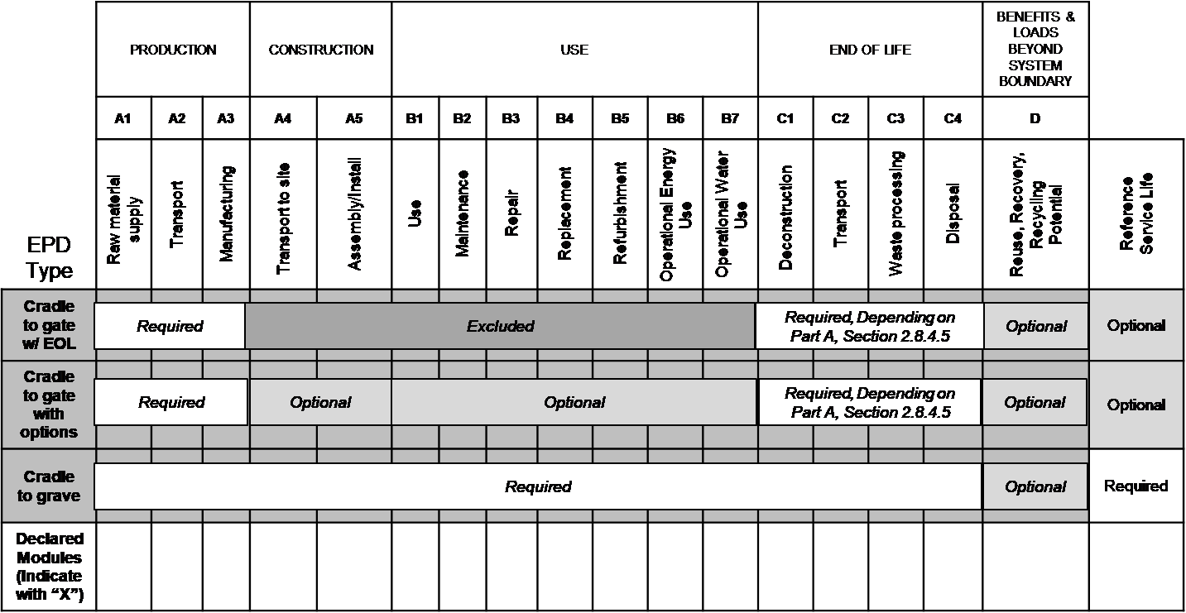

LCA Results from LCI
Results derived from the product LCI shall be reported as follows:
- Resource use indicators (Part A, Section 4.1, Table 6)
- Output flows and waste category indicators (Part A, Section 4.1.2, Table 7)
- Carbon emissions and removals (Part A, Section 4.6, Table 8)

LCA: Interpretation
Interpretation requirements for the Project Report are provided in Part A, Section 5.
An interpretation shall be provided in the EPD which discusses the assumptions and limitations associated with the interpretation of results as declared in the EPD, both methodology and data related.
This interpretation shall also include a description of the time frame and/or variance of the LCIA results if the EPD is valid for several products. An illustration of the results with figures is recommended in the EPD, e.g., for the dominance analysis, the distribution of impacts across the modules, the CO₂-balance, etc. as appropriate for a reader's understanding of the environmental profile of the declared product.

Additional Environmental Information

Results for Unfinished Steel
In addition to reporting results for Modules A1, A2, and A3 for fabricated products within the scope of this PCR (see Scope section), disaggregated results for Module A1 may additionally be reported for the production of one metric ton of mill product. These results may additionally be reported on the basis of one short ton using U.S. Customary units.

Environment and Health During Manufacturing
Measures relating to environmental and health protection during the product manufacturing process extending beyond national guidelines (of the production country) may be described, e.g., reference to a product safety data sheet (SDS), description of Environmental Management Systems or similar, programs addressing air emissions, waste water, noise, etc.

Environment and health during installation
Information should be provided in this section on the relationship between the product, the environment and health, including any possible harmful substances or emissions, e.g. reference to a product safety data sheet (SDS). Any recommendations concerning cleaning, maintenance, etc. of the declared product should be listed in Section ‎4 “Technical information on scenarios”. In establishing safe thresholds of exposure for humans, measures such as Reference Concentrations (RfC) or Reference Dose (RfD) can be used, which are established by US EPA and available in the Integrated Risk Information System database. In establishing safe thresholds of exposure for flora/fauna, measures such as Criteria Maximum Concentration (CMC) or Criterion Continuous Concentration (CCC) can be used, also established by US EPA and available as part of the National Recommended Water Quality Criteria. Other data sources can be used to establish safe thresholds of exposure for humans and flora/fauna, with justification.

Environmental Activities and Certifications
Other environmental activities, such as participation in recycling or recovery programs along with the details of these programs and contact information, may be provided.
For certifications applied to the product and listed in the EPD, a statement shall be included on where an interested party can find details of the certification program.

Further Information
A reference source for additional information may be provided here, e.g., homepage, reference source for safety data sheet.

Project Report and Supporting Documentation
The Project Report Content, Structure, and Accessibility requirements to support an EPD created using this document are provided in Part A: Section 2. Project Report elements include general information (Part A: Section 2.1), study goal (Part A: Section 2.2), study scope (Part A: Section 2.8), and the life cycle inventory analysis, impact assessment, and interpretation (Part A: Section 3, 4, and 5). Additionally, the Project Report shall include additional required supporting documentation specified in this sub-category Part B and according to Part A, Section 6.
As a general rule, all statements shall be documented with measured data (presented by the corresponding test certificates). In the case of non-verifiable substances, the limit of detection shall be included in the declaration. Interpreting statements such as “free of” or “entirely harmless” are not permissible.

References
The literature referred to in the Environmental Product Declaration shall be cited. Standards and standards relating to evidence and/or technical features already cited in the EPD do not need to be listed here. This Part B PCR document shall be referenced.
UL Environment
UL Environment General Program Instructions March 2020, version 2.5
Part A: Life Cycle Assessment Calculation Rules and Report Requirements UL Environment (December 2018, version 3.2)
Sustainability Reporting Standards
EN 15804:2019-04 - Sustainability of construction works — Environmental Product Declarations — Core rules for the product category of construction product.
ISO 14025: 2006 - Environmental labels and declarations — Type III environmental declarations — Principles and procedures
ISO 14040: 2006 - Environmental management – Life cycle assessment – Principles and framework
ISO 14044:2006 - Environmental management – Life cycle assessment – Requirements and guidelines
ISO 21930:2017 - Sustainability in building construction -- Environmental declaration of building products
Product Category Rule Guidance Development Initiative. Guidance for Product Category Rule Development. (August 28, 2014, version 1.0).
Relevant Federal Standards and SOPs
Environment Canada, National Pollutant Release Inventory (NPRI) (http://www.ec.gc.ca/inrp-npri/)
EPCRA 313 Toxic Release Inventory Reporting (U.S.) (https://www.epa.gov/toxics-release-inventory-tri-program) Accessed 08 December 2017.
US EPA, ORD/NRMRL/Sustainable Technology Division, Systems Analysis Branch, SOP No. S-10637-OP-1-0- Tool for the Reduction and Assessment of Chemical and other Environmental Impacts (TRACI), Software Name and Version Number: TRACI version 2.1, USER’S MANUAL, 24 July, 2012
Relevant PCRs
PCR Guidance-Text for Building Related Products and Services. Part B: Requirements on the EPD for Structural Steel. IBU. version 1.6, November 2017.

ASTM Standards

AISC 303‐10, Code of Standard Practice for Steel Buildings and Bridges. American Institute of Steel Construction, Chicago, IL. 2010.

This is an example flow diagram; products covered in this PCR may differ.
Here, non-competitive means a product comparison with an industry average or comparison between two products manufactured by the same producer.

